SECRETARIAT / SECRÉTARIAT
SECRETARIAT OF THE COMMITTEE OF MINISTERS
SECRÉTARIAT DU COMITÉ DES MINISTRES

Contact: Francine ARNOLD-PAULI
Tel: +33(0)3 88 41 32 79

Date: 29/11/2019
DD(2019)1420

Document distributed at the request of: | President of the Ministers’ Deputies

Documents distributed at the request of a Representative shall be under the sole responsibility of the said Representative, without prejudice to the legal or political position of the Committee of Ministers.

Meeting: | Informal exchange of views on cyberviolence against women and girls (Thursday, 12 December 2019 at 3 p.m.)

* * * * * * * * * * *

Document distribué à la demande de : | Président des Délégués des Ministres

Les documents distribués à la demande d’un/e Représentant/e le sont sous la seule responsabilité dudit/de ladite Représentant/e, sans préjuger de la position juridique ou politique du Comité des Ministres.

Réunion : | Échange de vues informel sur la cyberviolence à l’égard des femmes et des filles (jeudi 12 décembre 2019 à 15 heures)

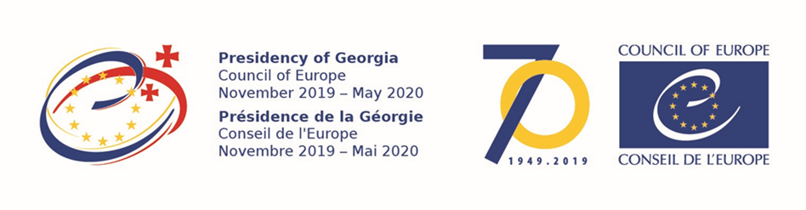

Informal exchange of views on cyberviolence against women and girls

Thursday 12 December 2019 at 3 pm

Committee of Ministers’ meeting room

Programme

Opening by:

- Ambassador Irakli GIVIASHVILI, President of the Ministers’ Deputies

Presentations by:

- Iris LUARASI, 1st Vice-President of GREVIO
- Adriane van der WILK, author of the study “Cyberviolence and Hate Speech online against women” for the European Parliament and consultant for the report “#HerNetHerRights” (European Women’s Lobby);
- Ute ZILLIG, Bff, Federal Association of Women’s Counselling and Rape Crisis Centres (Germany)

Discussion:

Other participants will be present and will be able to informally exchange views with the Deputies during the discussion, if need be:

- Marja RUOTANEN, Director of the Committees, Parliamentary Assembly (tbc)
- Claudia LAM, representative of the Office of the Commissioner for Human Rights
- Andreas KIEFER, Secretary General of the Congress (or his representative)
- Alexander SEGER, Secretary to the Cybercrime Convention Committee (T-CY)
- Gioia SCAPPUCCI, Secretary to the Committee of the Parties to the Convention on the Protection of Children against Sexual Exploitation and Sexual Abuse (Lanzarote Convention)

Summing-up by the President.

Background documents:
Council of Europe Gender Equality Strategy 2018-2023
CM/Rec(2019)1 - Recommendation of the Committee of Ministers to member States on preventing and combating sexism
Parliamentary Assembly Recommendation 2098 (2017) - Ending cyberdiscrimination and online hate
CM/AS(2017)Rec2098-final - Reply adopted by the Committee of Ministers

More:
https://www.coe.int/en/web/istanbul-convention/resources
https://www.coe.int/en/web/cybercrime/cyberviolence

* * *

Concept note

The growing use of information and communication technologies have provided a new dimension for the perpetration of acts of violence against women and the expression of sexism. Forms of cyberviolence, which are manifold and evolve alongside shifting digital tools, are an integral part of the widespread issue of violence against women. Despite the lack of global data, research shows that women are disproportionally targeted and suffer serious consequences from cyberviolence, such as physical, sexual, psychological or economic harm or suffering. Cyber violence also significantly impacts women’s exercise of free speech. Among specific groups of women who experience cyberviolence are journalists, politicians, activists and human rights defenders, specifically targeted for their activity in an attempt to silence or discredit them. Girls and young women are also particularly exposed to this form of violence. At the same time, cyber violence is an integral part of the pattern of abuse of women at the hands of former or current intimate partners.

More and more spaces where acts of violence against women are committed, perpetrating cybercrime, impairing freedom of expression: cyberviolence against women displays intricate features that require a comprehensive answer. In the face of this global phenomenon, the Committee of Ministers, under its Georgian Presidency, wishes to hold an open discussion on cyber violence against women and girls. Bringing together civil society specialists and members of various Council of Europe bodies, the discussion will allow to assess the impact of cyberviolence against women and girls, to take stock of the different instruments addressing the issue and to identify areas where cooperation could be further developed to ensure a comprehensive approach to cyberviolence against women and girls.

Informal exchange of views on Cyberviolence against women and girls, 12 December, 2019, Strasbourg
Informal exchange of views at the level of Ministers’ Deputies was held on 12 December 2019 in Strasbourg, on cyberviolence against women and girls, within the framework of the Georgian Presidency of Committee of Ministers of the Council of Europe.
The event was planned within the framework of the Georgian Presidency priorities
Mr. Irakli Giviashvili, the Permanent Representative of Georgia to the Council of Europe, President of the Ministers’ Deputies opened the event. In his speech, the President of Ministers’ Deputies highlighted the significance of combatting violence against women and girls and underlined the priority of this issue in the context of the Georgian Presidency. He also spoke about awareness-raising activities organized by the Council of Europe's Gender Equality Section within the 16-day campaign against gender-based violence and the link between such activities and crime prevention. Irakli Giviashvili noted that cyberviolence against women and girls is a relatively new phenomenon, largely driven by the rapid development of information and communication technologies.
Within the event, presentations were held by Iris Luarasi, first Vice-President of the expert group on Preventing and Combating Violence against Women and Domestic Violence (GREVIO), Adriane van der WILK, author of the study “Cyberviolence and Hate Speech online against women” and Ute Zilling, representative of the Federal Association of Women’s Counselling and Rape Crisis.
Speakers discussed the issue in light of Istanbul Convention, and touched other instruments of the Council of Europe dealing with the issue of cyberviolence against women (for example, recommendation of the Committee of Ministers on sexism adopted in 2019). Speakers also touched upon the challenges of protecting victims and prosecuting offenders. Following the presentations, substantial discussion was held between the participants. In conclusion, the issues discussed at the informal meeting of the Ministers' Deputies were summarized by Mr. Irakli Giviashvili, President of the Ministers’ Deputies.
The event was attended by representatives of diplomatic missions accredited at the Council of Europe and various representatives of the structural units of the Council of Europe.
Georgia took over the Presidency of the Committee of Ministers of the Council of Europe on 27 November 2019 for a six-month period, which will last until the meeting of the Council of Europe's Committee of Ministers in Tbilisi on 15 May 2020.

